《欧标》使用说明
User Guide for the EBCL Resources Query
零、概述
欢迎使用 “欧洲汉语能力标准”（European Benchmarks for Chinese Language I & II，简称《欧标》）在线查询系统 。 本系统旨在方便使用者便捷地检索《欧标》各级别不同交际方式和交际策略能力描述及相应的参考例句和相关词汇与汉字等信息，希望可为欧洲的汉语二语学习、教学和研究（如汉语二语课程设置与评估、教材编写和教师发展等）及交流提供一个参考性的资源与平台的服务。
本系统内容主要来自《欧标》项目II期（B1至C1），依据的是《欧洲语言共同参考框架》（简称《欧框》）2020年增补版（ CEFR Companion Volume）。虽然系统也包括前段I期（A1至A2+）的内容，但因其依据的是2001年版的《欧框》，故在形式和内容上和增补版都有些出入，日后还需做些相应的调整和修改。本系统中A级别的信息均还是项目一期的成果，相关的能力描述一开始根据《欧框》增补版进行更新，敬请期待。
《欧标》虽名为“标准”，但实质上和《欧框》一样，也是个在有一定“基准”基础上的参考框架。因受研发人员能力、时间和资源等条件的限制，目前的成果无疑还有很多需改进之处。和《欧框》一样，《欧标》也将会不断与时俱进。为此，本系统设置了开放性的反馈机制（见六），并会阶段性地对内容进行更新。欢迎欧洲的汉语二语教学同仁继续关心和积极参与《欧标》的应用与不断完善工作，也欢迎世界各地的同道不吝赐教，提供宝贵意见和建议，共同推进《欧标》的建设和发展。
0. Overview
Welcome to the online resource query system for the European Benchmarks for Chinese Language I & II, hereafter referred to as EBCL. This system is designed to help users conveniently search for EBCL descriptors across different levels, modes of communication and communication strategies, together with corresponding sample sentences, vocabulary and Chinese characters. It is intended to serve as a reference resource and platform for the learning, teaching and research of Chinese as a second language in Europe, including curriculum design and assessment, textbook development, teacher development and wider academic exchange.
The content of this system is mainly drawn from Phase II of the EBCL project, covering levels B1 to C1, and is based on the 2020 CEFR Companion Volume. The system also includes content from Phase I of the project, covering levels A1 to A2+. However, as the Phase I content was based on the 2001 version of the CEFR, there are some differences in both format and content when compared with the Companion Volume. Further adjustments and revisions will therefore be needed in due course. At present, all information at A levels in this system remains based on the outcomes of Phase I of the project. The relevant descriptors are currently being updated in line with the CEFR Companion Volume, and further updates will follow.
Although EBCL is described as a set of “benchmarks”, it is, in essence, a reference framework, as is the CEFR itself, developed on the basis of certain benchmarked principles. Due to limitations in researcher capacity, time and resources, the current outcomes will inevitably require further improvement. Like the CEFR, EBCL will continue to evolve over time. For this reason, the system includes an open feedback mechanism, as explained in Section 6, and its content will be updated periodically. We warmly welcome colleagues involved in the teaching of Chinese as a second language in Europe to continue supporting and participating in the application and further development of EBCL. We also welcome valuable comments and suggestions from colleagues around the world, so that we may jointly advance the development of EBCL.

一、基本检索操作
进入页面后，您可以按照以下条件进行筛选：等级（目前涵盖 A1、A2、B1 、B2、C1五个级别）、语言形式、交际策略 、其他组合条件各筛选项可单独使用，也可叠加使用，从而更精准地定位到所需内容。 筛选结果将显示为三种形式：汉字、词汇、例句。

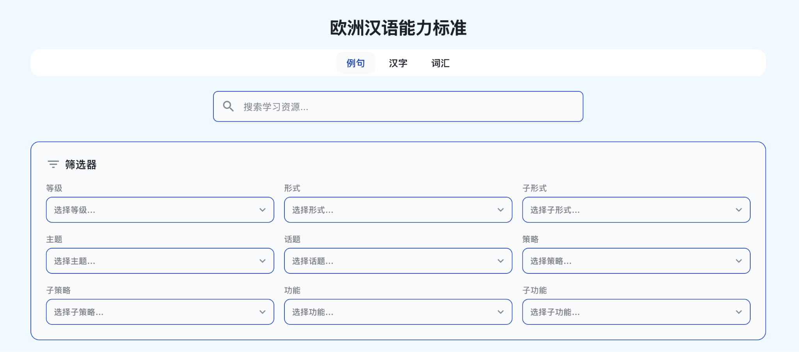

1. Basic Search Operations
After entering the page, users can filter results according to the following criteria: level, currently covering A1, A2, B1, B2 and C1; language form; communication strategy; and other combined search conditions.
Each filter can be used independently or in combination with others, allowing users to locate the required content more precisely.

Search results are displayed in three forms: characters, words and sample sentences.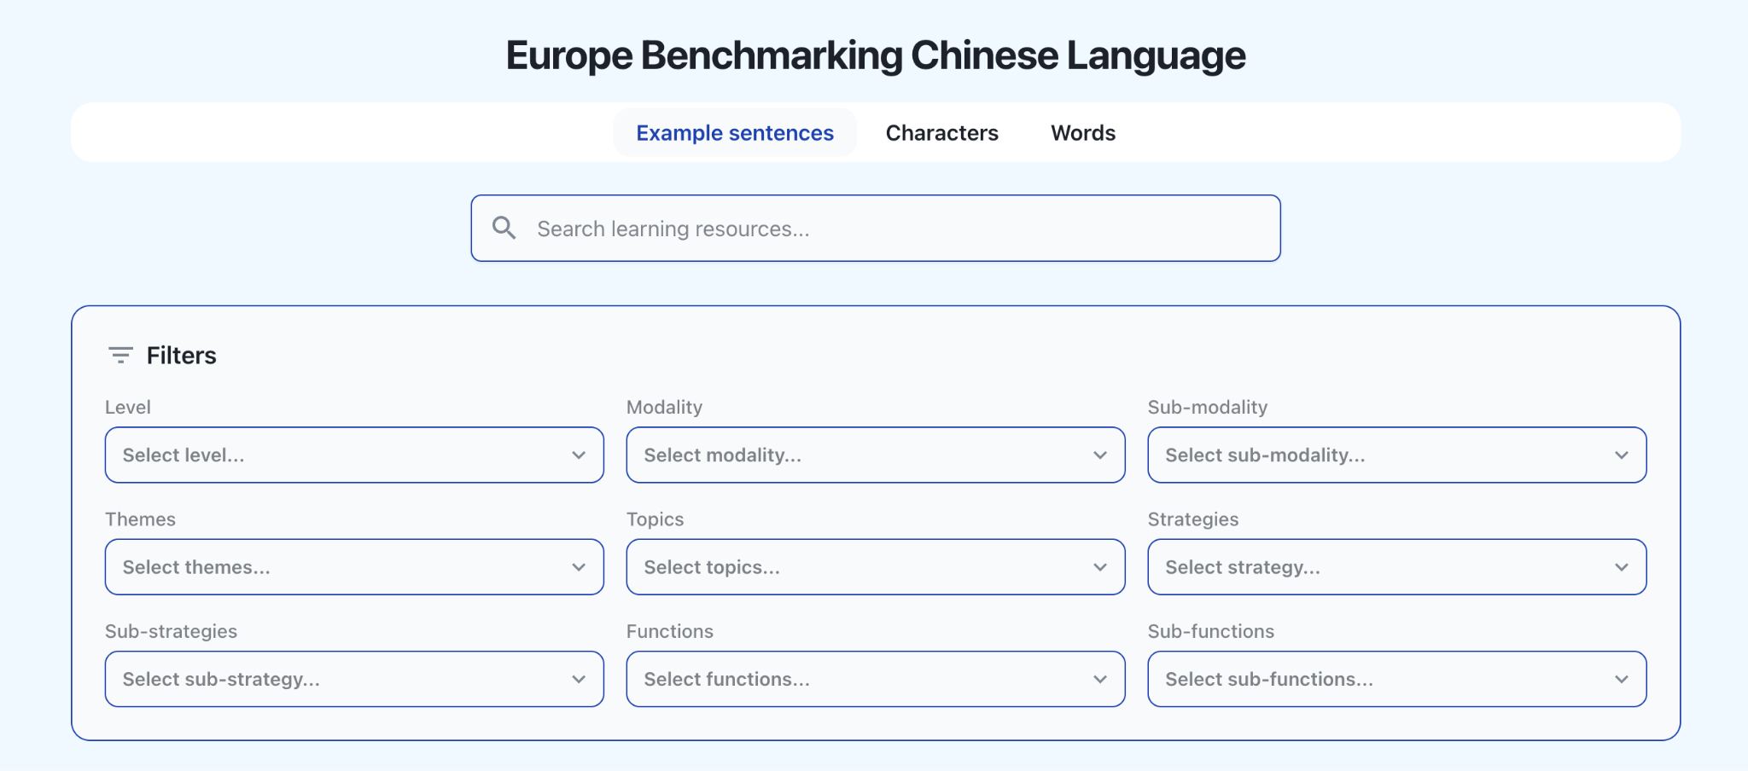
二、逐级查询
本系统支持从等级—主题—功能等多个维度逐层筛选，用户可按需组合查询条件，以精准定位到目标学习资源。
如图所示，下图展示了以 A1 等级、个人情况 为主题的查询结果。系统共检索出 18条相关例句，例如：“我家有四口人：爸爸、妈妈、弟弟和我。”
通过此类逐级查询方式，用户可以清晰地了解不同 CEFR 等级下对应的语言内容与交际场景（等级与形式，主题、话题、子话题或功能、子功能），为教学与学习提供分级参考。

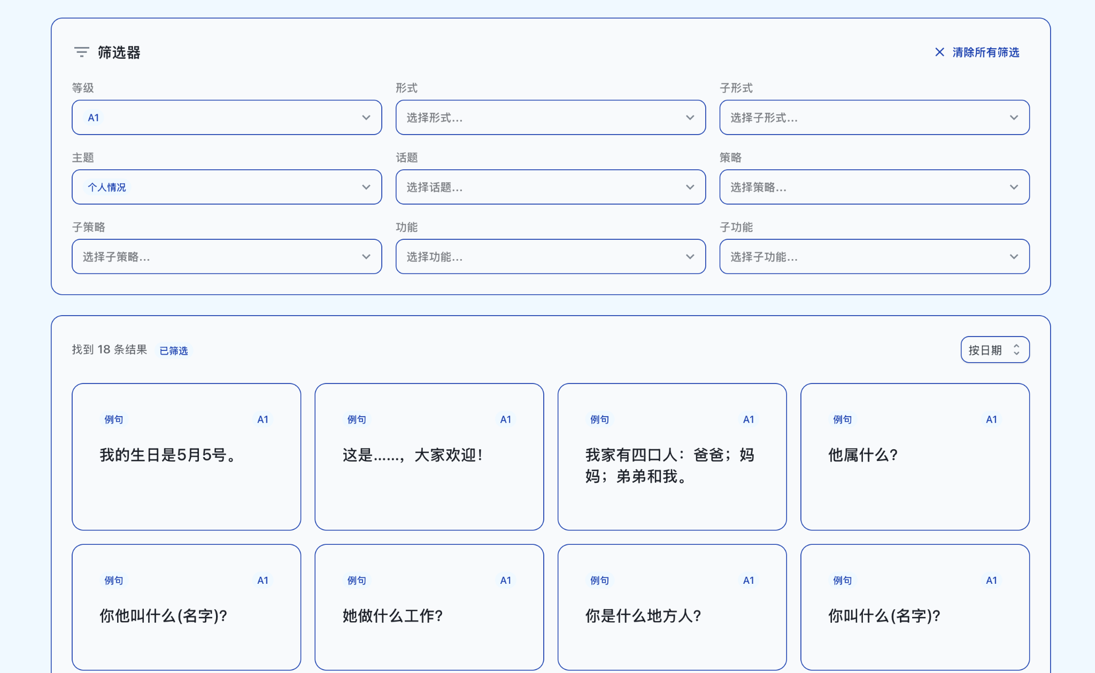

2. Level-by-Level Search
The system supports step-by-step filtering across multiple dimensions, including level, theme and function. Users may combine search criteria according to their needs in order to locate relevant learning resources accurately.
As shown in the example, the query results are based on Level A1 and the theme of personal information. The system retrieves 18 relevant sample sentences, such as:
“My family has four members: my father, my mother, my younger brother and me.”
Through this type of level-by-level search, users can clearly identify the language content and communicative contexts corresponding to different CEFR levels, including level and form, theme, topic, sub-topic, function and sub-function. This provides a graded reference for both teaching and learning.

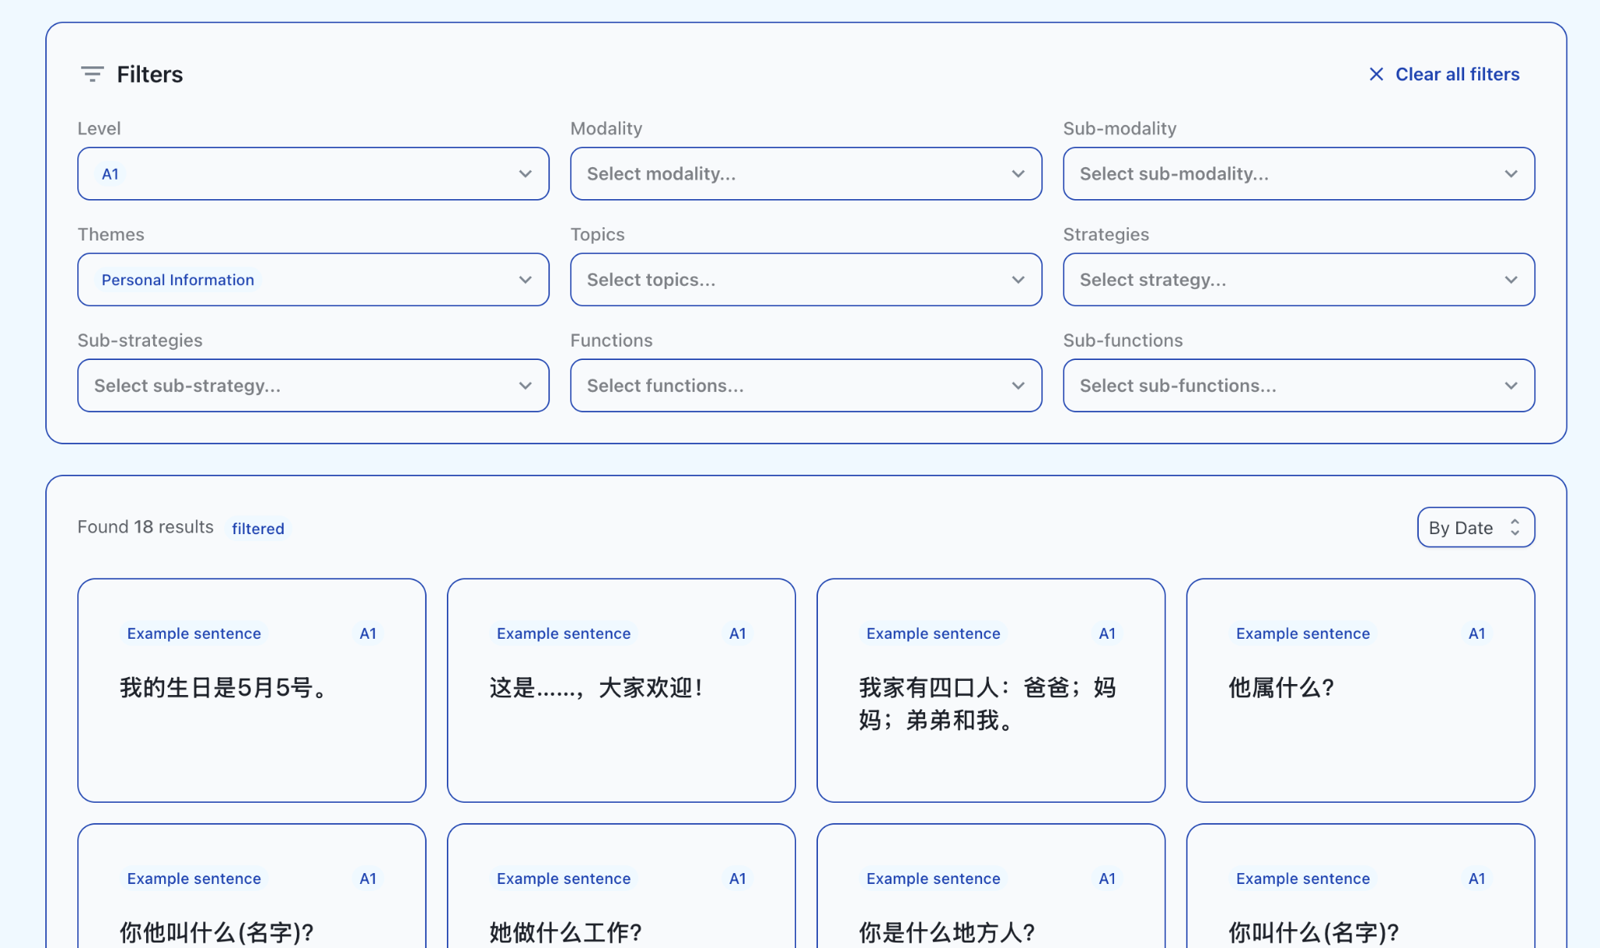
三、例句查询
如您希望查找包含某一特定词语的所有例句，可在“例句”栏目中输入关键词。 例如：输入“学习”，系统将显示全部包含“学习”一词的例句，并在结果中自动高亮显示该词。 点击任一例句，可查看更详尽的信息： 对应的 CEFR 等级、所关联的具体能力描述量表、所体现的交际策略。
在后续版本中，系统还将陆续为每个例句补充主题、话题及功能标签，以便教学参考。
查询结果可依照添加日期或CEFR等级排列显示。

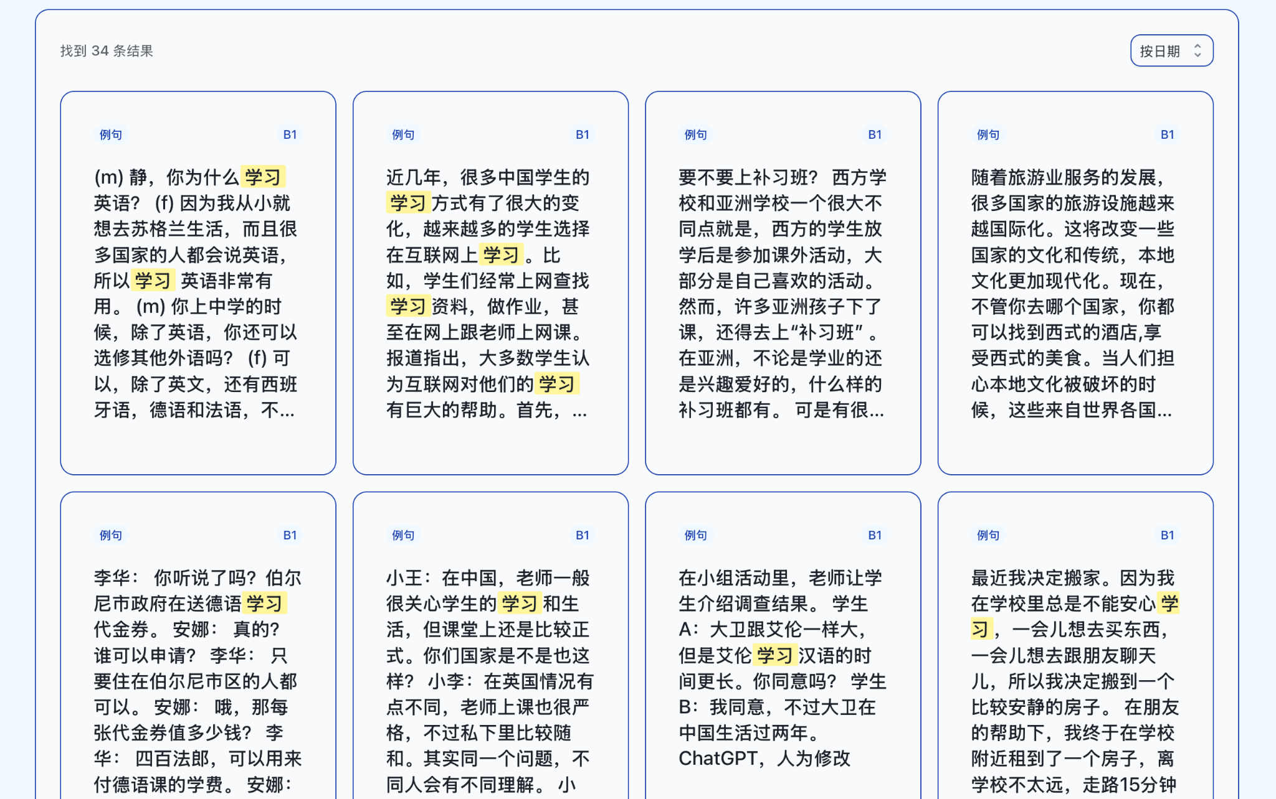

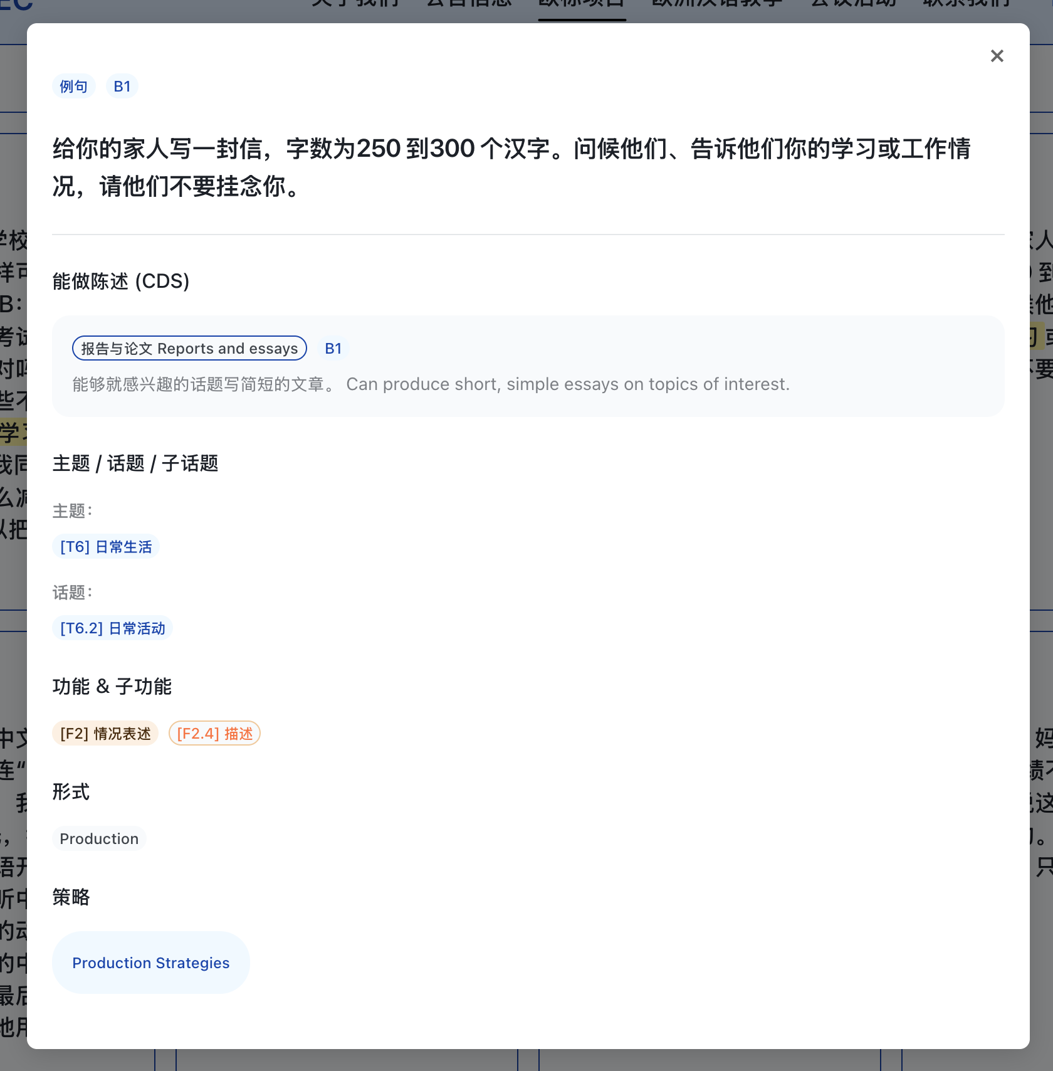

3. Sample Sentence Search
If users wish to find all sample sentences containing a specific word or expression, they may enter a keyword in the “Sample Sentences” section.
For example, if the word “学习” is entered, the system will display all sample sentences containing this word and automatically highlight it in the results.
By clicking on any sample sentence, users can view more detailed information, including the corresponding CEFR level, the specific descriptor scale it is linked to, and the communication strategy it reflects.
In future versions, the system will gradually add theme, topic and function labels to each sample sentence to provide further support for teaching reference.
Search results can be sorted by date added or by CEFR level.
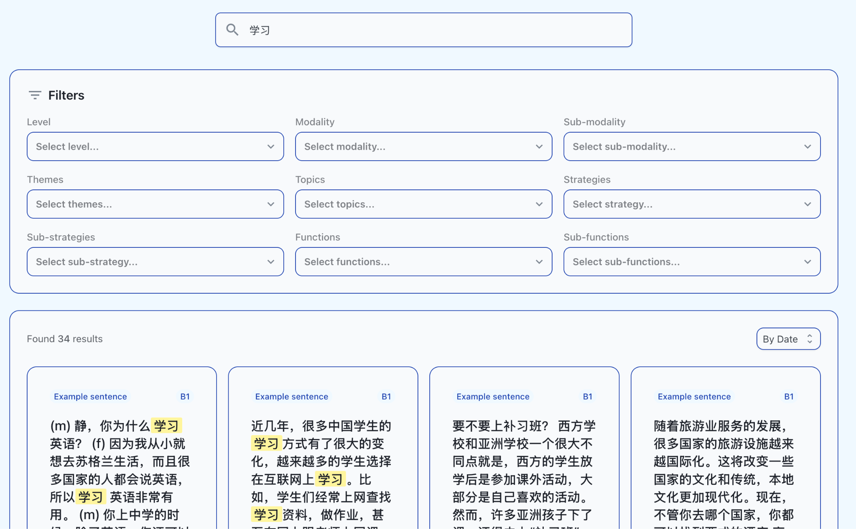

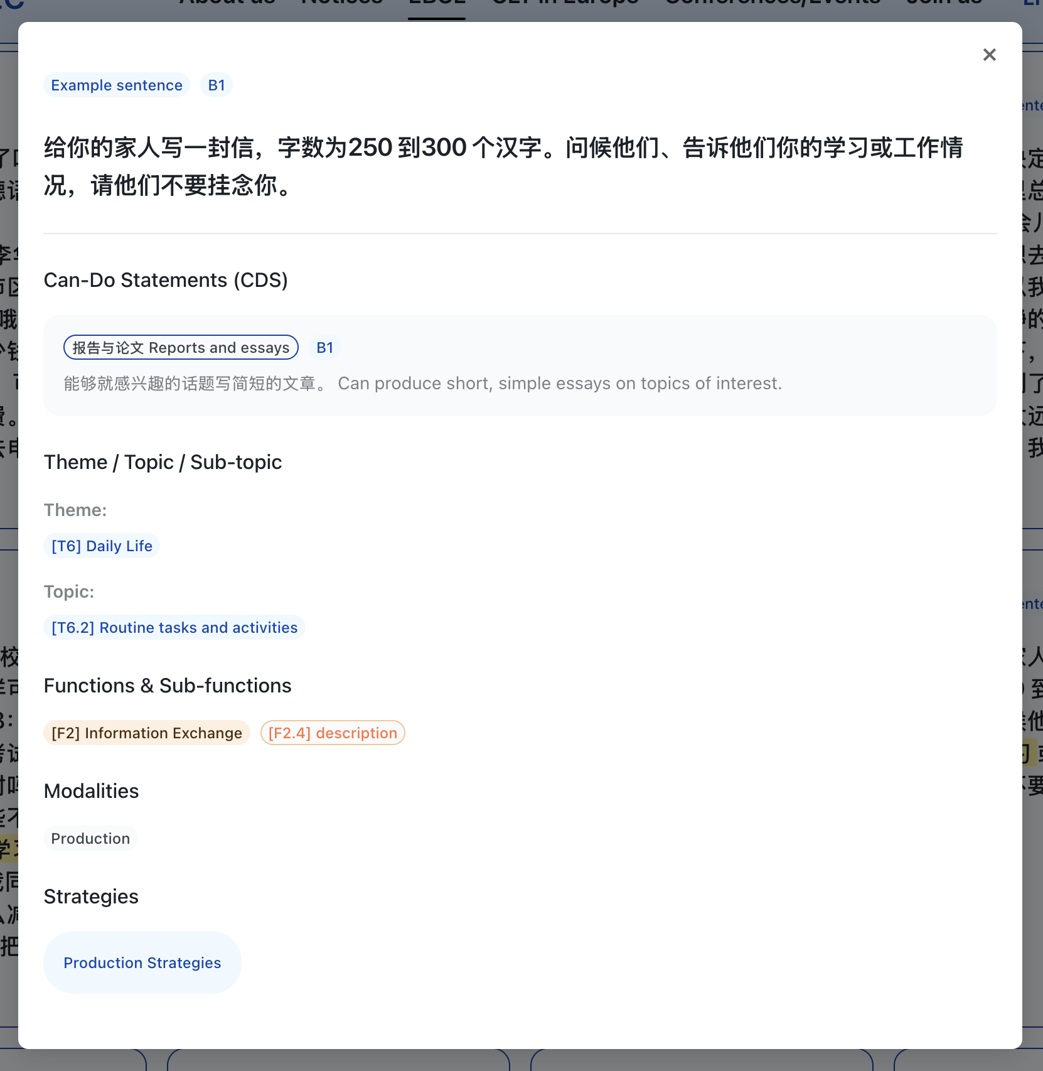

四、汉字查询
在“汉字”栏目中，您可以： 通过筛选器逐层筛选汉字； 或直接输入目标汉字，例如“我”。 点击搜索结果后，即可查看该字对应的 CEFR 等级及相关能力描述。

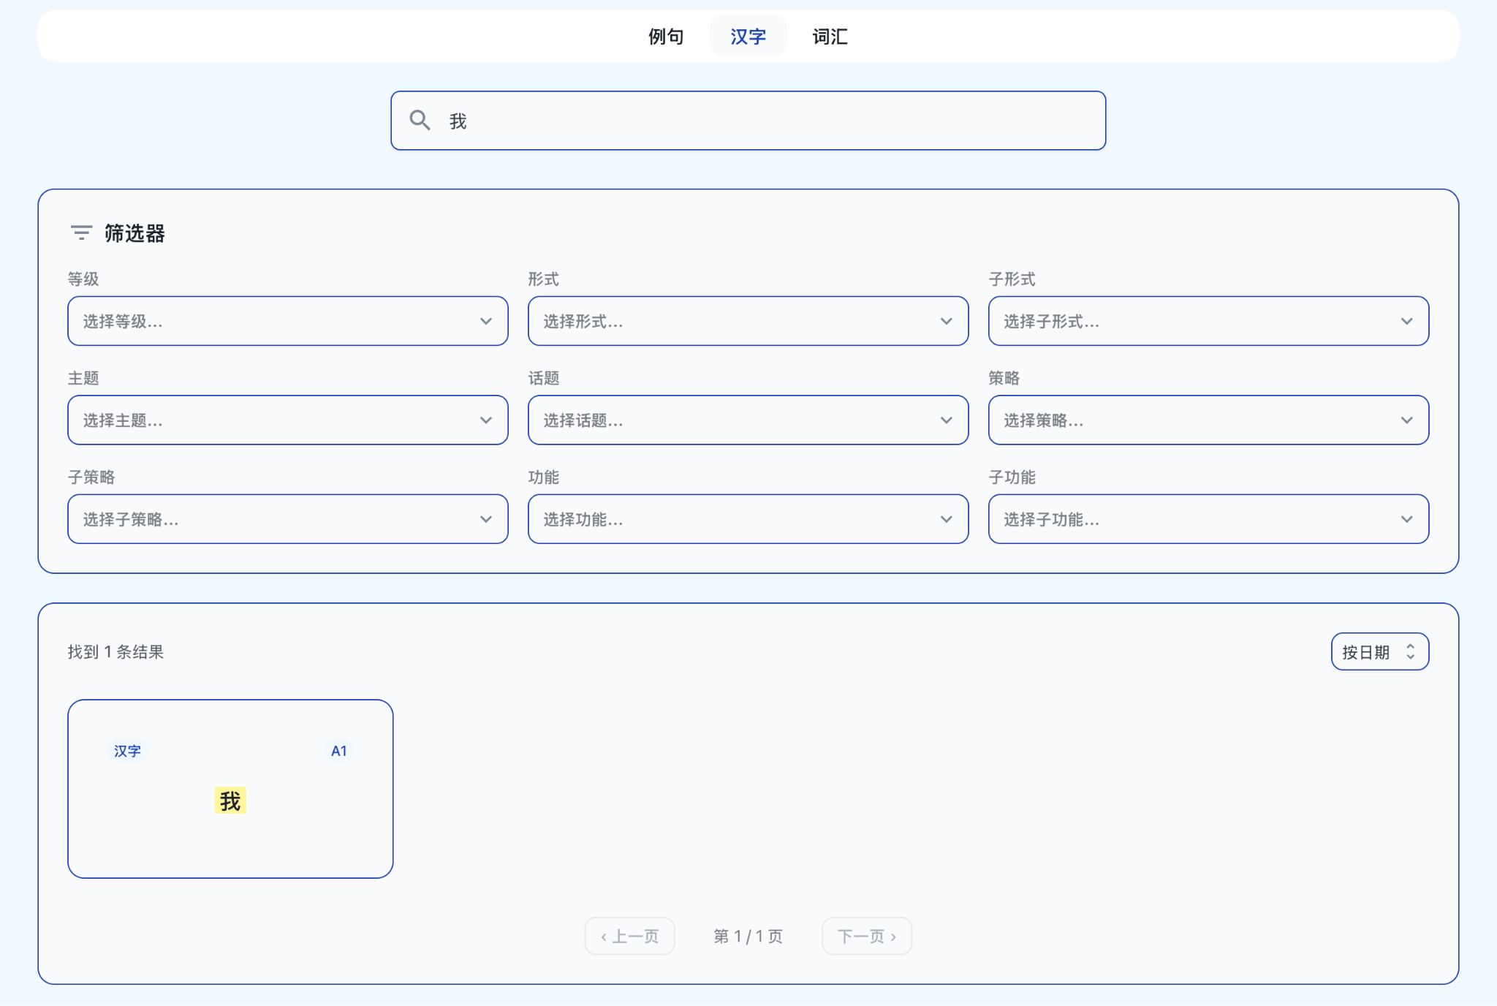

4. Chinese Character Search

In the “Chinese Characters” section, users can either:

filter Chinese characters step by step using the available filters; or directly enter a target character, for example “我”.

After clicking on a search result, users can view the CEFR level corresponding to the character, as well as the related descriptors.

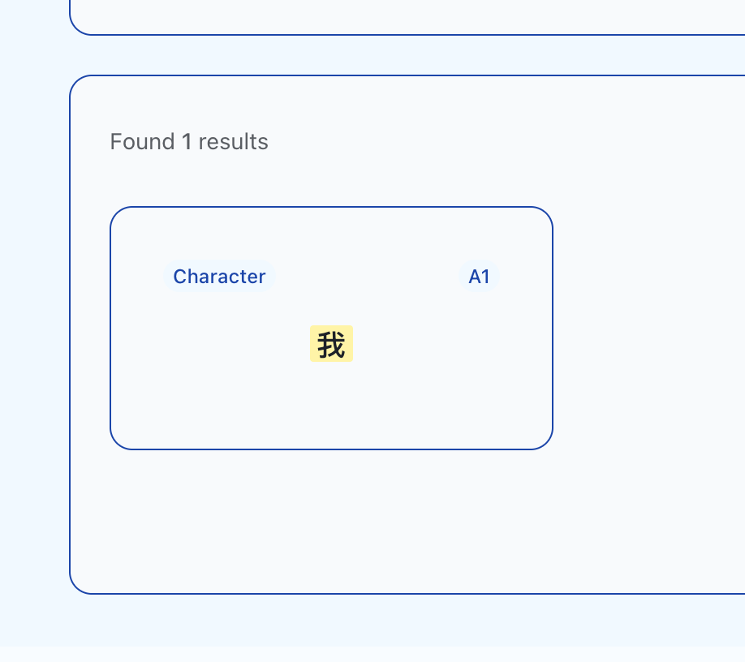

五、词汇查询
在“词汇”栏目中，您同样可以选择逐层筛选，或直接输入关键词进行查询。 例如： 输入“雪山”，可获得该词汇对应的 CEFR 等级； 输入单字“雪”，则会显示所有包含“雪”字的已收录词汇。

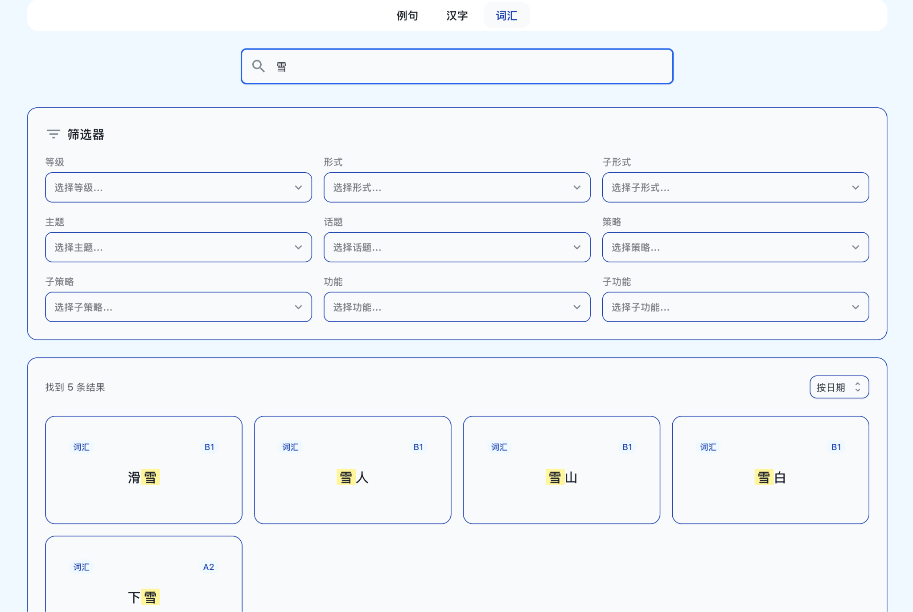

5. Vocabulary Search

In the “Vocabulary” section, users can similarly choose to filter results step by step or directly enter a keyword for searching.

For example, entering “雪山” will return the CEFR level corresponding to this word. Entering the single character “雪” will display all recorded vocabulary items that contain this character.

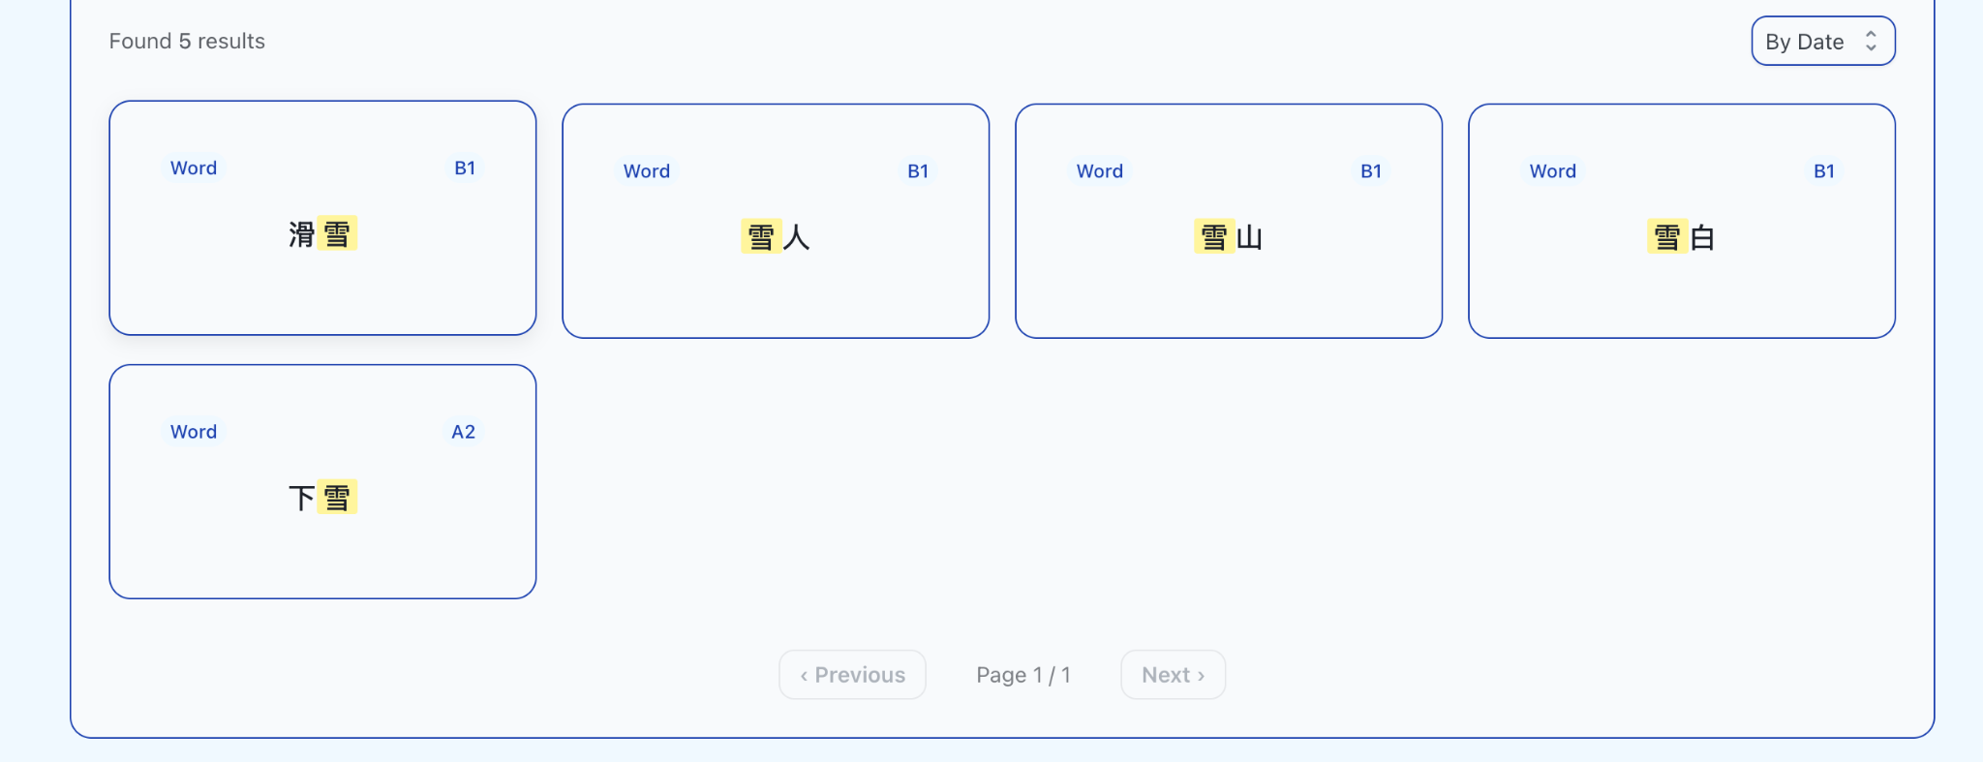

六、用户反馈与登录功能
如果您希望进一步为我们的项目提供建议或意见，例如： 对例句所体现的主题、话题、功能等有不同理解； 或者您认为有更好的例句可以补充， 我们建议您点击页面右上角的“登录”。 在弹出的新页面中，您可以： 创建账户（填写邮箱并设置密码），以提交反馈； 或使用邮箱验证码方式快捷登录。

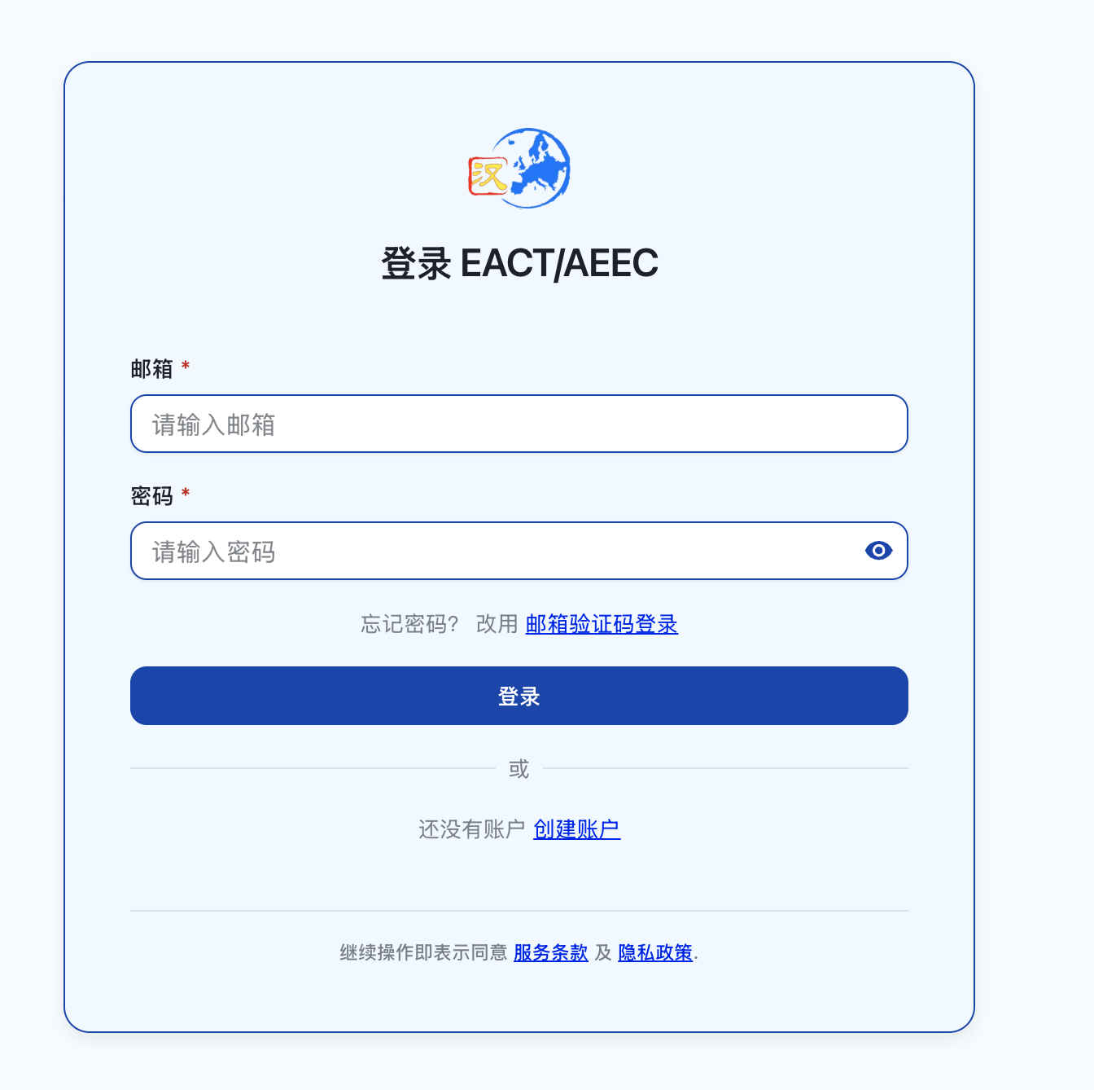
对于已创建账户的用户，我们开放了编辑功能，以收集您的建设性意见。 反馈提交后，系统后台的专业管理员将对您的建议进行审核。 审核通过后，我们将以电子邮件形式与您确认更改并同步更新。

6. User Feedback and Login Function
If users wish to provide further suggestions or comments on the project, for example, if they have a different interpretation of the theme, topic or function reflected in a sample sentence, or if they believe that better sample sentences could be added, we recommend clicking “Login” in the upper right-hand corner of the page.
In the pop-up page, users can: create an account by entering an email address and setting a password, in order to submit feedback; or use an email verification code for quick login.
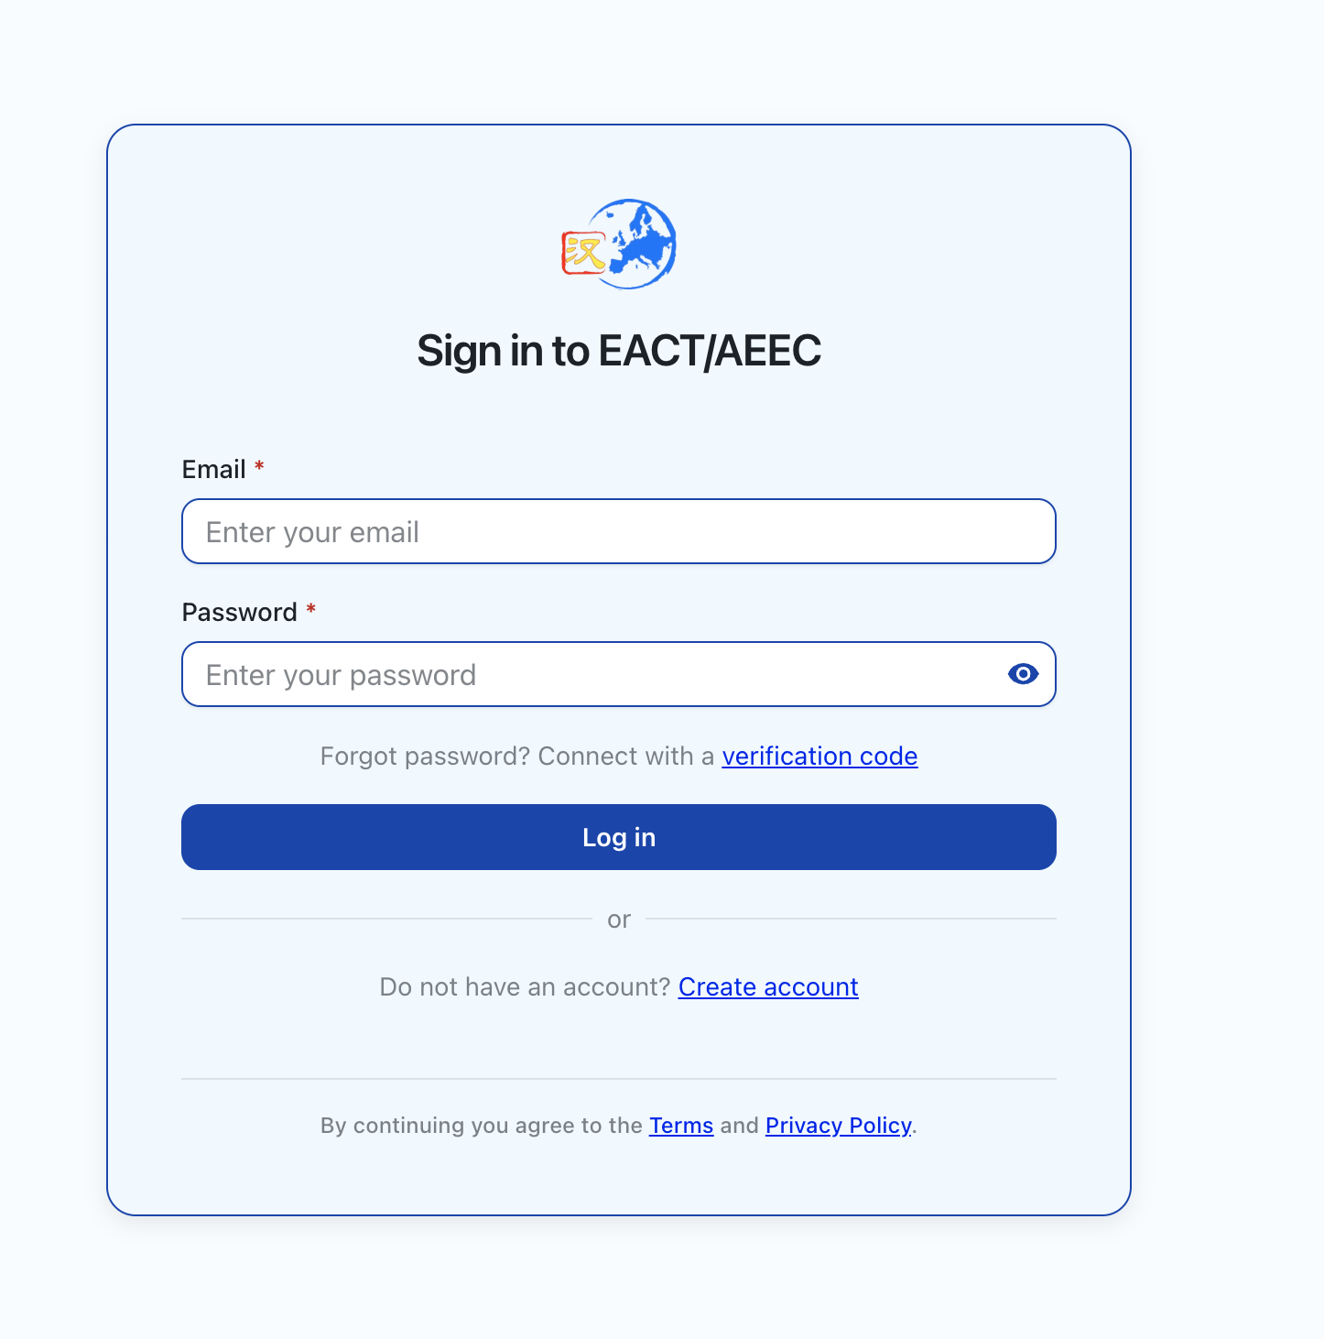
For users who have created an account, we have enabled an editing function to collect constructive feedback. After feedback is submitted, the professional administrators of the system will review the suggestions in the backend. Once approved, we will confirm the changes with the user by email and update the system accordingly.

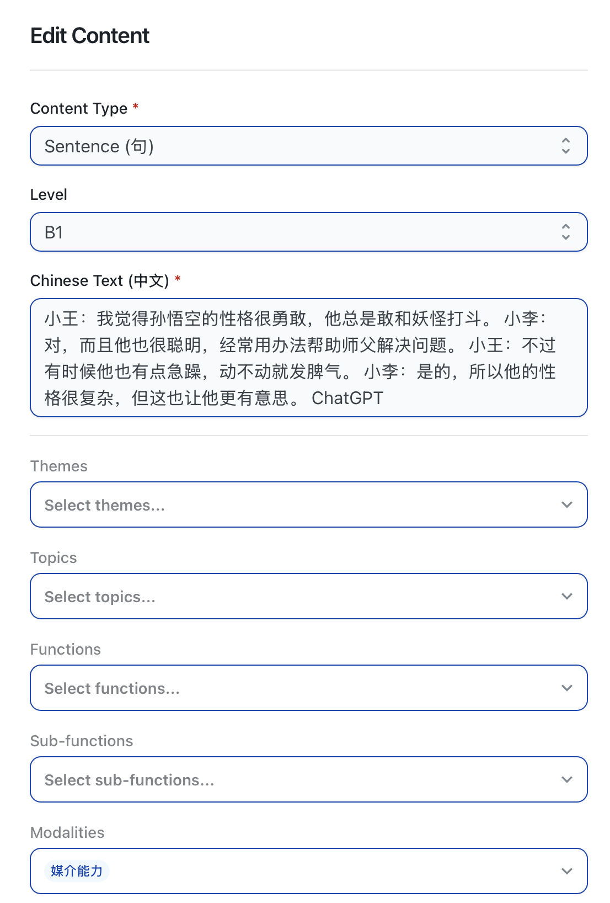

七、未来更新
我们将持续完善系统功能，包括： 中英文对照版“具体能力描述量表（Can-do statements）”的发布； 按 CEFR 四大领域（语言产出、语言接收、互动能力、媒介能力）进行分类展示； 提供注册用户的意见反馈与隐私保护说明。若需进一步了解项目，请访问欧汉会官方网站主页 www.ouhanhui.eu上的相关信息。

7. Future Updates
We will continue to improve the functions of the system, including:
the publication of bilingual Chinese-English versions of the specific descriptor scales, or Can-do statements;
classification according to the four major CEFR domains: production, reception, interaction and mediation;
and the provision of feedback guidance and privacy protection information for registered users.
For further information about the project, please visit the relevant pages on the official EACT website at www.ouhanhui.eu.

